1. Search for Figma template and convert it o html CSS.

Part 2:

1. Given a string, that contains a special character together with alphabets (‘a’ to ‘z’ and ‘A’ to ‘Z’), reverse the string in a way that special characters are not affected.

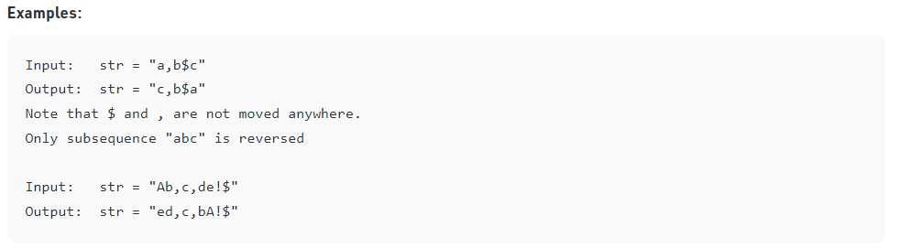

1. Given a string s of lowercase letters, we need to remove consecutive vowels from the string Note : Sentence should not contain two consecutive vowels ( a, e, i, o, u).

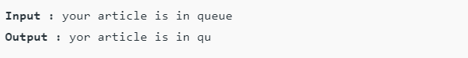

1. In JavaScript there is several ways to create objects, define an object that represent Tsionet structure.
2. In JavaScript with are using the … operator over objects arrays and function, using this operator
   1. Clone array of numbers
   2. Get array first and second elements
   3. Get array first and second elements and the rest put them in one element
   4. Define simple object of person and get the first name and last name using …
   5. Define function that receive a and b elements and the rest of elements put them in args property. (Rest Parameter and Spread Operator).
3. Define object of Tsionet using class in JS, add the function Add Student and Delete Student.
4. what is arrow function in JavaScript, define two functions at least in two ways using function keyword and arrow function (anonymous function).
5. Create html page that include CSS and JavaScript and connect the to html page.